MobiliseYourCity

Guidance Document

Visual identity, voice and editorial standards
August 2026

How to use this guide
This document brings the 2026 visual identity, institutional messaging and editorial rules into one practical standard for MobiliseYourCity (MYC). Use it when preparing reports, presentations, web and social content, event materials, publications and partner communications.

Contents
How to use this guide 1
1. Brand at a glance 3
2. Name, acronym and terminology 4
3. MobiliseYourCity Brand Voice 5
4. Editorial style 6
5. Approved boilerplate 7
6. Core terminology in three languages 9
7. Logo system 10
8. Colour system 12
9. Typography 13
10. Graphic elements 14
11. Partner logo reference 15

Brand at a glance

Our purpose
MobiliseYourCity is a European-led global partnership that helps enabling cities and countries to plan, prepare and implement sustainable, low-carbon, resilient and inclusive urban mobility, while strengthening their ability to access and mobilise climate and development finance.

Our messages
Plan for investment  SUMPs and NUMPs create an evidence-based framework for prioritising mobility needs and building coherent investment pipelines. | Move from plans to delivery  Technical assistance, pilots and project preparation help turn plans and policies into implementable, finance-ready projects.
Build local capability  Methods, tools and capacity building are adapted to diverse local contexts and updated through experience on the ground. | Connect a global partnership  MYC brings together member cities and countries, donors, implementing partners and knowledge networks around sustainable mobility.

Current proof points
Measure | 2026 figure
Grants backing the Partnership | More than EUR 120 million
Financing leveraged | EUR 4.4 billion
Member cities | 82
Population represented by member cities | 172 million people
Member countries | 16
02

Name, acronym and terminology

Approved forms
MobiliseYourCity  Use the full name for first mention, prominent institutional references and formal attribution. | MYC  Permitted in internal and external communications after the full name has been introduced.
MobiliseYourCity Partnership  Use when referring to the institution as a partnership. Capitalise “Partnership” when used as part of the institutional name. | MobiliseYourCity Secretariat  Use for the team that coordinates the Partnership.

External communications
On first mention, write “MobiliseYourCity”. Use “MYC” thereafter when this improves readability. Do not rely on the acronym alone when the audience is unlikely to know the Partnership.

Avoid
Avoid | Use instead
Mobilise Your City | MobiliseYourCity
MobilizeYourCity | MobiliseYourCity
Mobiliseyourcity | MobiliseYourCity
MobiliseYourCity network / initiative | MobiliseYourCity Partnership
Beneficiary partners | Member cities and countries

MobiliseYourCity Brand Voice
Our voice should communicate trust and expertise and should be consistent across our channels. It should be smart and professional, as we represent all our partners. While we have clear and explicit values, we aim to remain politically neutral to respect our member cities and countries.

Trustworthy  Be precise. Use verified figures, dates and sources. Avoid exaggerated claims and unsupported superlatives. | Expert  Use evidence and technical knowledge, but explain specialised terms when the audience may not know them.
Practical  Prefer active verbs and concrete outcomes: plan, prepare, test, finance, implement, learn and scale. | Inclusive  Write about people, cities and countries with respect and agency. Use “member cities and countries”, not “beneficiaries”.
Locally grounded  Acknowledge that mobility systems and political contexts differ. Avoid presenting one model as universally applicable. | Non-partisan  Focus on evidence, public value and agreed mobility objectives. Do not endorse political parties or candidates.

Editorial style

Official languages
The working language of the MobiliseYourCity Secretariat is British English. MYC also communicates and publishes in French and Spanish. Use professional, plain language and define acronyms on first use unless they are universally understood by the intended audience.

Numbers, units, currency and dates
Item | Rule | Example
Numbers | Spell out zero to ten in prose; use numerals from 11 onwards. | ten cities; 11 countries
Thousands / decimals | Use a comma for thousands and a period for decimals in English. | 12,500.00
Units | Use SI abbreviations in lowercase where applicable, with a space between number and unit. | 15 km
Currency | Use the ISO currency code before the amount. Write million and billion in full in narrative text. | EUR 4 million; EUR 4.4 billion
Dates in prose | Use day month year. Do not use ambiguous numeric dates in narrative communications. | 12 August 2026
Dates in filenames / data | Use day.month.year where a compact machine-readable format is useful. | 12.08.2026
Locations | Use a comma between city and country. | Bouaké, Côte d’Ivoire
Percentages | Use numerals and the % sign without a space. | 44.5%

Approved boilerplate

Short boilerplate
MobiliseYourCity is a European-led global partnership that helps enabling cities and countries to plan, prepare and implement sustainable, low-carbon, resilient and inclusive urban mobility, while strengthening their ability to access and mobilise climate and development finance.

Full boilerplate
MobiliseYourCity (MYC) is a European-led global partnership that supports cities and countries in developing and emerging economies to go from sustainable urban mobility strategies to investment-ready programmes. Backed by more than €120 million in grants (primarily from the EU, France and Germany) MYC plays a catalytic role in mobilising domestic and international finance. At its core, MYC provides a platform to align planning, project preparation and financing around coherent mobility pipelines.

To date, MYC has leveraged €4.4 billion in financing. Building on the European-developed Sustainable Urban Mobility Plan (SUMPs) methodology, the initiative demonstrates how European planning approaches can translate into tangible investment at scale: we have reached 82 member cities representing 172 million people and 16 member countries.

MobiliseYourCity’s four service areas

Mobility Planning
MobiliseYourCity supports cities and countries in developing Sustainable Urban Mobility Plans (SUMPs) and National Urban Mobility Policies and Investment Programmes (NUMPs) that provide a structured, evidence-based framework for identifying and prioritising urban mobility investments. By anchoring project identification and investment pipelining within approved plans and policies, MobiliseYourCity helps generate coherent, demand-driven project pipelines aligned with national climate commitments (NDCs), local governments’ urban development objective, and global political priorities and programmes such as Global Gateway priorities. This reduces fragmentation and increases the credibility of proposed investments for development partners and investors.

Implementation Support
Through targeted technical assistance, institutional strenghthening, pilot projects and project preparation support, MobiliseYourCity helps de-risk early-stage urban mobiliy projects. This includes strengthening governance and regulatory frameworks, improving data availability, testing innovative solutions at pilot scale, supporting the definition of technically sound and socially inclusive project concepts and carrying out project preparatory studies to improve projects’ implementation readiness. These interventions improve project quality and bankability, reduce preparation costs, and increase the likelihood that large-scale investments successfully progress to financing and implementation.

Capacity building and methodologies
To enable sustained and scalable transformation in urban mobility, MobiliseYourCity develops and disseminates the frameworks and tools, and strengthens capacities that enable effective planning and implementation. As a global knowledge hub on urban mobility, MobiliseYourCIty operates as a platform for exchange as well as for consolidating and translating lessons from implementation into new or revised methodologies, tools, and capacity-building offers that can be applied across diverse contexts.

Advocacy and Outreach
MobiliseYourCity advances decarbonised and socially just mobility systems by raising awareness, shaping dialogue, and building support among key stakeholders through targeted advocacy and outreach. Through strategic communication, participation in high-level events, and regular dissemination of evidence and results, the Partnership helps mobilise broader engagement and strengthens the case or sustainable mobility solutions by demonstrating their tangible benefits for cities and their residents.

Core terminology in three languages
Use established institutional terms consistently across English, French and Spanish. For specialised terminology or long programme titles, use the current official MYC glossary rather than creating a new translation locally.

English (UK) | French | Spanish
MobiliseYourCity Partnership | Partenariat MobiliseYourCity | Alianza MobiliseYourCity
Donor | Bailleur de fonds | Donante
Implementing partner | Partenaire de mise en œuvre | Socio ejecutor
Knowledge / Network Partner | Partenaire de connaissance | Socio de conocimiento
Member city | Ville membree | Ciudad miembro
Sustainable Urban Mobility Plan (SUMP) | Plan de Mobilité Urbaine Durable (PMUD) | Plan de Movilidad Urbana Sostenible (PMUS)
National Urban Mobility Policy or Investment Programme (NUMP) | Programme National d’Investissement et politique Nationale de mobilité urbaine (un PNMU)  Politiques et Programmes d’Investissement Nationaux de Mobilité Urbaine | Programa de Inversión Nacional y Política Nacional de Movilidad Urbana (un PNMU)  Programas de Inversión y Politicas Nacionales de Movilidad Urbana

Access the complete glossary here.

Logo system
The MobiliseYourCity identity can be used as a combined symbol-and-wordmark (the imagotype), as a stacked combined mark for narrower formats, or as the symbol alone in limited contexts. Always use supplied artwork; never reconstruct the logo from typed text.

For more details on the use of our logo, please refer to the Visual Identity Guidelines.

Primary horizontal imagotype
Preferred on light or warm-white backgrounds (available in all MYC theme colours).
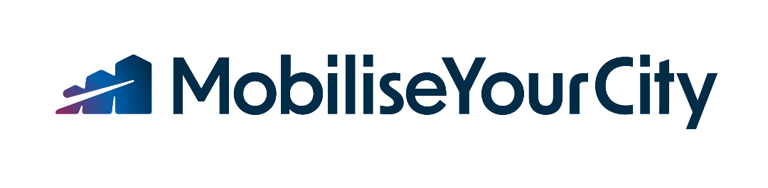

Stacked (or vertical) imagotype
Use where horizontal space is limited (available in all MYC theme colour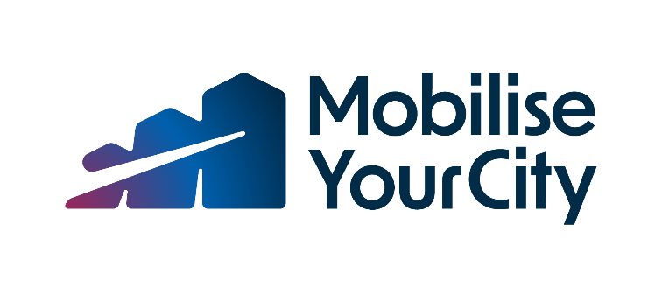

Reversed horizontal imagotype
Use the white version on approved dark colour fields.

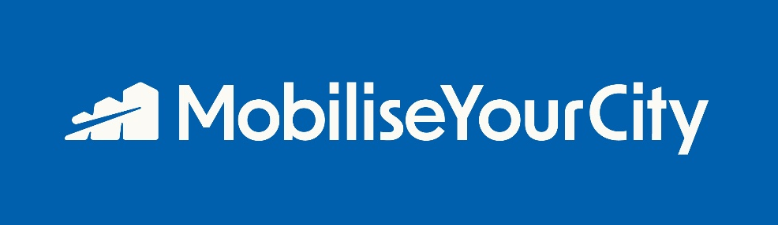

Symbol
Use for profile picture, social media posts, favicons, small identifiers or where the brand name is already clearly present.


Colour versions
Approved logo versions follow the official palette. Use the gradient version as the default on light backgrounds. White/reversed versions may be used on dark blue, fuchsia, green or cyan fields when contrast is clear. Do not invent additional colourways.
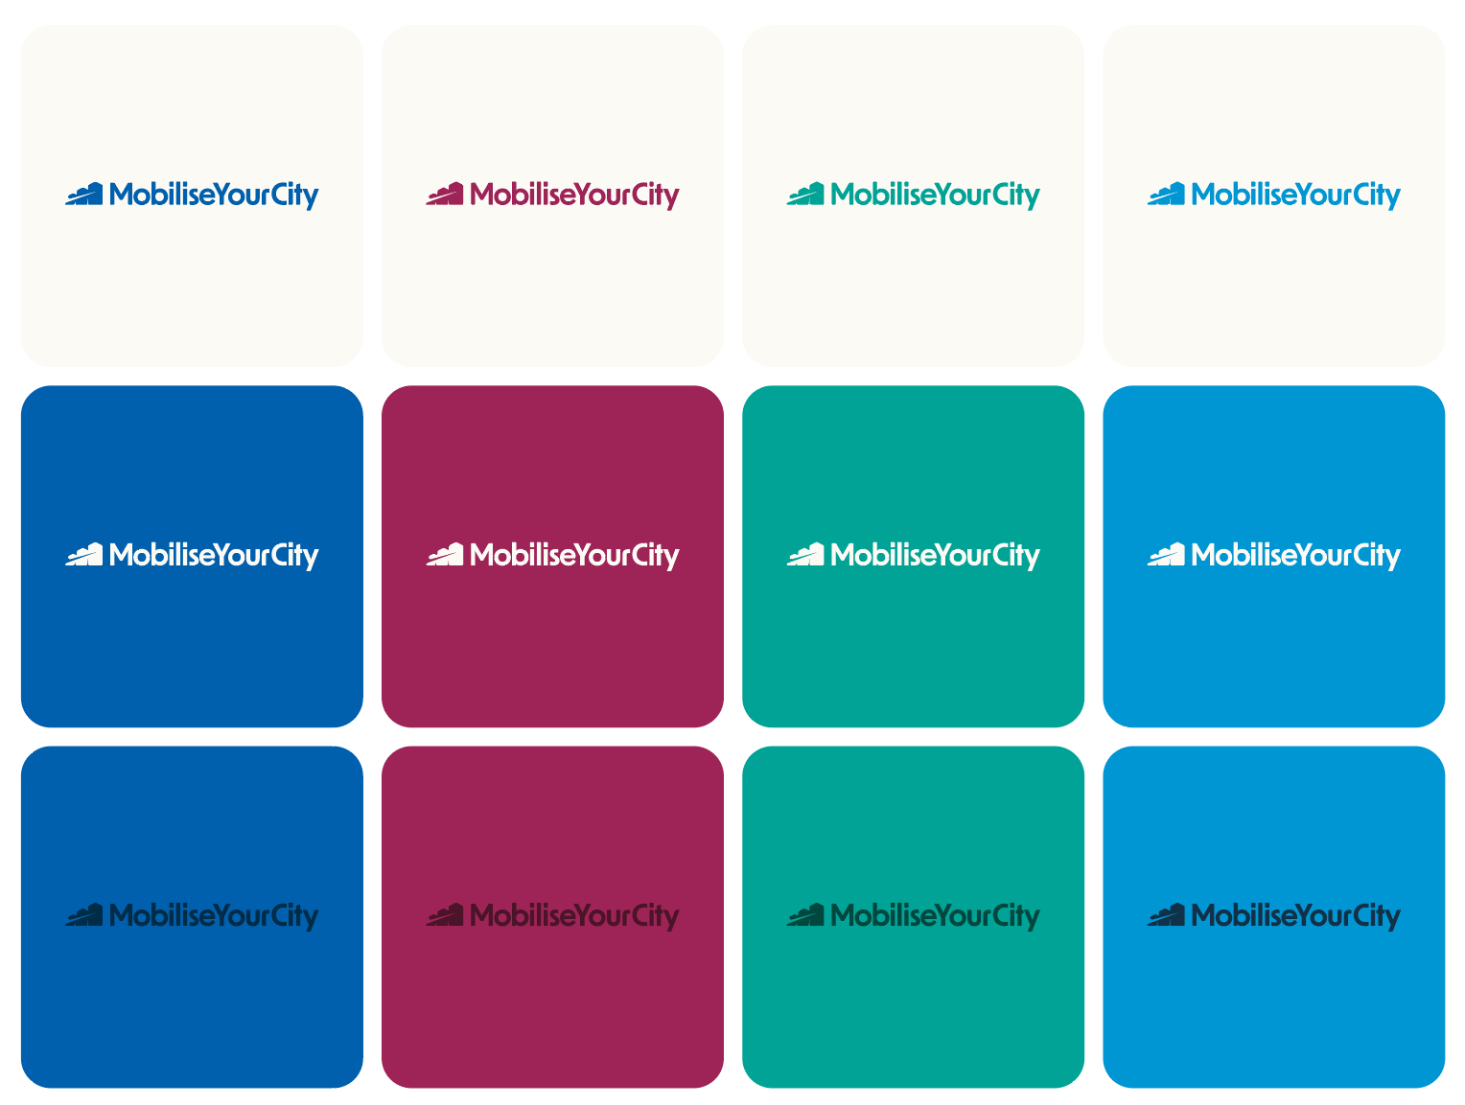

Colour system
The palette is built around four colour families. Fuchsia and cyan are the main tones; blue and green extend the system. Black, grey, warm white and pure white provide neutral support. Use colour families deliberately rather than mixing all colours in a single composition.

Fuchsia | Cyan | Blue | Green
Dark  #4B1428 | Dark  #113148 | Dark  #002C47 | Dark  #02473F
Core  #9E2458 | Core  #0096D3 | Core  #0060AD | Core  #00A396
Light  #F257A1 | Light  #4ECDF4 | Light  #A4DAFF | Light  #9AE8DA
Super light  #FF83BE | Super light  #80E1FF | Super light  #D2EDFF | Super light  #D2FFFB
Neutral colours
Black  #000000 | Grey  #DADBD6 | Warm white  #FCFAF5 | Pure white  #FFFFFF

Typography
Radio Canada Big  Medium, Medium Italic | AaBb 01234
Manrope  Light, Regular, Medium, Bold | AaBb 01234

Radio Canada Big is used for titles and subtitles. Manrope is used for body text.

Radio Canada Big (size 12)
The quick brown fox jumps over the lazy dog.
AaBbCcDdEeFfGgHhIiJjKkLl
MmNnOoPpQqRrSsTtUuVvWwXxYyZz
0123456789
.,!?@#$%^&*()

Manrope (size 12)
The quick brown fox jumps over the lazy dog. AaBbCcDdEeFfGgHhIiJjKkLl MmNnOoPpQqRrSsTtUuVvWwXxYyZz
0123456789
.,!?@#$%^&*()

Typography rules
- Use sentence case for headlines. Do not set headlines in all caps.
- Avoid extremely loose or tight line spacing and letter spacing.
- Do not mix multiple fonts or weights within a single headline unless a template already defines the treatment.

Graphic elements
The graphic system extends the movement embedded in the MYC symbol. Lines, illustrations and rounded information boxes create a recognisable visual language across presentations, reports and digital content.

 | Path lines  Use the line as an accent that suggests path, trajectory and progress. Keep it fluid and secondary to the message; do not use it as random decoration.
 | Illustrations  Use approved illustration assets that follow the line-based system. Keep colours within a single theme and prefer clean or warm-white backgrounds.
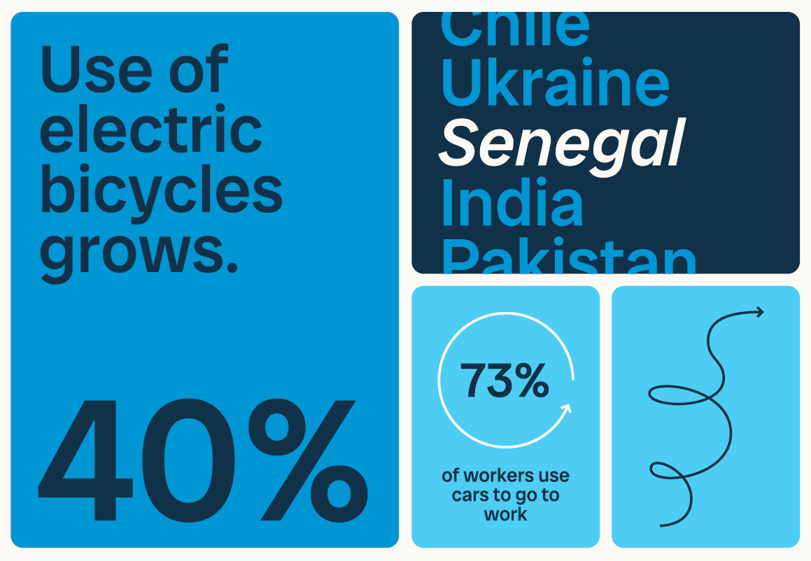 | Rounded boxes  Use rounded information boxes to organise statistics, short messages, infographics and calls to action. Apply tonal variations from one colour family to create hierarchy.

Partner logo reference
The following organisations are shown in the 2026 Branding Kit. Before external publication, confirm that the partner set and any donor acknowledgement wording are current for the specific communication product.

Donors
  European Commission |   AFD | 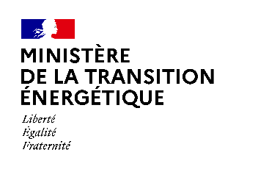  French Ministry for the Energy Transition
  FFEM | 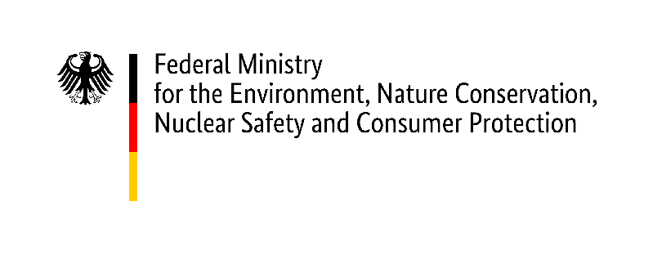  German Federal Ministry for the Environment |   German Federal Ministry for Economic Cooperation and Development

Implementing Partners
  AFD | 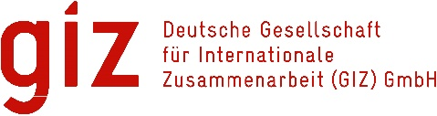  GIZ |   Codatu

Asian Development Bank

Knowledge & Network Partners
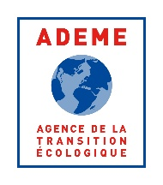  ADEME | 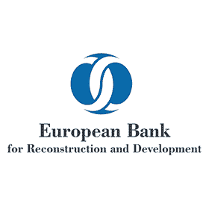  EBRD |   Cerema |   KfW
  Wuppertal Institute | 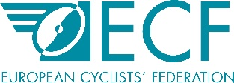  European Cyclists' Federation | 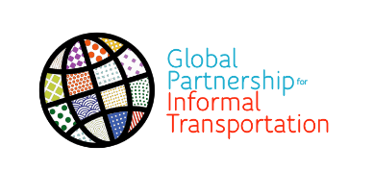  Global Partnership for Informal Transportation | 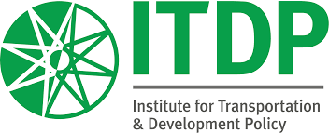  ITDP
  UCLG |   UN-Habitat |   CONCITO | 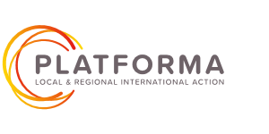  PLATFORMA

Despacio

