Standard Template for SUMP Report
  - Insert your subtitle here
Other logos, if necessary

2022
For more information:
MobiliseYourCity Partnership Secretariat, Brussels
https://mobiliseyourcity.net/
email: contact@mobilseyourcity.net

Title:
Printed and distributed:
Authors:
Contributors:
Reviewers:
Photo Credits:

Copyright:
This publication is subject to copyright of the MobiliseYourCity Partnership and its partners, authors and contributors. Partial or total reproduction of this document is authorised for non-profit purposes, provided the source is acknowledged.
Disclaimer:
The content presented in this document represents the opinion of the authors and is not necessarily representative of the position of the individual partners of the MobiliseYourCity Partnership.

Donors
Implementing partners
Knowledge and Network partners
In collaboration with

Contents
1. Executive summary 3
1.1. Background of the SUMP 3
1.2. Objective and scope 3
1.3. Methodology 3
1.4. Document structure 3
1.5. Key results 3
1.6. Conclusions and recommendations 3
2. Process and management structure 3
2.1. Context of developing the SUMP 3
2.2. Process overview 3
2.3. Stakeholder involvement 4
3. Status Quo Analysis 4
3.1. Institutional and regulatory framework 5
3.2. Financial framework 5
3.2.1. Budgetary and financial aspects: 5
3.3. Planning framework 6
3.4. Demographic data and urban development 6
3.5. Mobility and transport 6
3.5.1. Transport infrastructure 6
3.5.2. Mobility demand and traffic 6
3.5.3. Active Mobility 7
3.6. Accessibility 7
3.7. Road Safety 7
3.8. Urban freight 8
3.9. Social aspects of mobility 8
3.9.1. Gender and mobility 8
3.9.2. Other groups with specific mobility needs 8
3.9.3. Transport poverty 8
3.9.4. City Livability 8
3.10. Environment 8
3.10.1. Air pollution and GHG emissions data and analysis 8
3.10.2. Noise 8
3.11. New solutions for mobility and transport 8
3.12. Baseline 8
4. Vision and objectives 11
4.1. Vision 11
4.2. Objectives, targets, and indicators 11
4.3. Planned and proposed measures 12
4.4. Identification of integrated packages of measures 12
4.5. Short- and long-term scenarios 12
4.5.1. Business-as-usual scenario (BAU) 12
4.5.2. Alternative sustainability scenarios 12
5. Selected scenario and actions 12
5.1. Selected scenario 12
5.2. Selected measures 12
5.3. Cost estimates 13
5.4. Implementation planning and funding 14
5.4.1. Funding sources 14
5.4.2. Financing plan 14
5.4.3. Implementation schedule 14
5.5. Capacity development strategy 16
6. Monitoring & Reporting 16
6.1. Core indicators 16
6.2. Other indicators 16
6.3. Monitoring management 16
7. Appendix 18
7.1. List of contributors to the SUMP development 18
7.2. Timetable of SUMP development 18
7.3. Data collection methods 18
7.4. Participation summary 18
7.5. Description of scenarios 18
7.6. Long list of potential measures 18
7.7. Traffic model report 18
7.8. Data reporting timetable 18
7.9. References 18
7.10. Index of Boxes 18
7.11. Index of Diagrams 18
7.12. Index of Images 18
7.13. Index of Tables 18
7.14. Glossary 18
7.15. Area plans and future development charts 18

STANDARD TEMPLATE FOR SUMP REPORT

Executive summary

Background of the SUMP

Objective and scope

Methodology

Document structure

Key results

Conclusions and recommendations

Process and management structure

Context of developing the SUMP

Process overview

- The SUMP time horizon:
- The SUMP study area:
- Team and development process:
Basic element 1. Map of the functional area. Note: Source, Integrated Mobility Plan for
Greater Ahmedabad Region 2031

Stakeholder involvement
Basic element 2. Stakeholders and their involvement in the SUMP process (Template). List the identified stakeholders and identify their level of involvement.

Involvement in SUMP process | Type of stakeholders
 | Political support | Transport network competence | Technical expertise | Public support
Strong involvement | City mayor | Public transport company
Medium  involvement |  |  | University
Low involvement |  |  |  | Police

Status Quo Analysis
- Description of the institutional, regulatory and financial framework
- Presentation of the main transport problems, opportunities, strengths and weaknesses based of a proper analysis of the data of all transport modes such as the following aspects:

Institutional and regulatory framework
- National policies and regulatory framework:
- Local policies and regulatory framework:
- Institutional capacities:

Basic element 3. Presentation of institutional and regulatory aspects. Note: Source, Lagos (Nigeria)
Non-Motorised Transport Policy
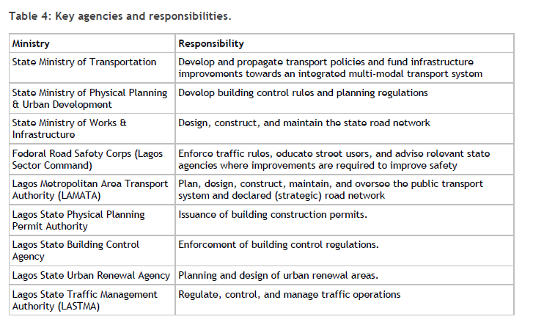

Financial framework

Budgetary and financial aspects:

Basic element 4. Presentation of projects in the past five years (table above) and of the planned projects (table below) (Templates).

Presentation of projects in the past five years
Project / Activity | Implementation period | Responsibility | Funding source | Cost
Extension of the bicycle network | 2014-2017 | City of … | Municipal budget and national funding | 100.000$
…
Presentation of planned projects (2-5 years)
Project / Activity | Implementation period | Responsibility | Funding source | Cost

Planning framework

Demographic data and urban development

Mobility and transport
Basic element 5. Map of transport infrastructure

If an overall map of transport infrastructure is not available, maps with different transport aspects can be included (e.g. one map for rail, one map for streets etc.)

Transport infrastructure
- Inventory of transport infrastructure and transport services supply
- Indicator on existing sustainable infrastructure
- Mobility services

Mobility demand and traffic
- Mobility demand and traffic
- Modal split

Basic element 6. Spatial analysis of road safety regarding accidents and fatalities

Active Mobility

Accessibility

Road Safety
Basic element 7. Spatial analysis of road safety regarding accidents and fatalities
Detailed analysis on street level only if data is available

Basic element 8. Fatalities over time. Note: Source, Note: Source, Plan de Movilidad Segura de
Medellin 2014-2020
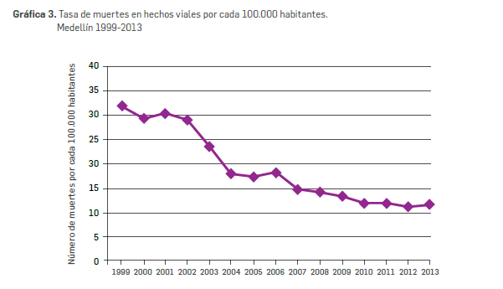

Urban freight

Social aspects of mobility

Gender and mobility

Other groups with specific mobility needs

Transport poverty

City Livability

Environment

Air pollution and GHG emissions data and analysis

Noise

New solutions for mobility and transport

Baseline

Basic element 9. Analysis of the status (baseline analysis) of the transport system (Template)

Functions/ Transport mode | Modal share | Quality of infra-structure | Safety and liveability | Environment and health | Equitable accessibility | Status of measure implementation | Main recommendations
Walking | 12% | Poor | Many accidents on road crossings near schools | Less and less pupils walking to school | Some areas lack walkable access to parks and sports facilities | Low activity. New “walk to school” campaign | Traffic safety measures are needed
Cycling | 7%
Public transport (bus, tram, metro, train etc.) | …. | Good | Some bus stops need repair | New bus fleet has been installed, decreased impact on air quality | Reduced fare for unemployed, but infrequent buses to poor outskirts | High activity, public transport strategy planned
Vehicle sharing (car, bicycle, e-scooter etc.) | ….
Private motorised transport (car, motorcycle etc.)
Multimodality (train station, interchanges) | n/a
Freight | n/a
ANALYSIS |  |  | Traffic safety needs to be prioritised

Basic element 10. MYC SUMP Core Indicators
Please provide the current baseline for each indicator.

MYC SUMP Core Indicators | Baseline
Access to public transport (in %)  Proportion of the population living within 500 meters or less of a public transport stop with a minimum 20 minutes service at peak hour, or have access to a shared mobility system with comparable service for money | %
Air pollution  Mean urban air pollution of particulate matter (in mg PM2.5) at road-based monitoring stations | mg PM2.5
Road safety  Fatalities by all transport accidents in the urban area on a yearly basis. As defined by the WHO, a death counts as related to a traffic accident if it occurs within 30 days after the accident) | Pers. (in thousands)
Modal split  Share of public and non-motorised transport of total urban transport (in pkm -not trip) | %
GHG emissions from transport [tonnes CO2 (eq.)/cap. per year)  Well-to-wheel GHG emissions by all urban area passenger and freight transport modes | MtCO₂e  per year

Additional Indicators | Base line
Commercial speed  Average speed of a mode of transport between the two terminals, including all operational stops | km/h
Mobilised public and private funding
Others (city specific)

Vision and objectives

Vision

Objectives, targets, and indicators

Basic element 11. SUMP strategic indicators and targets (Template)
Indicators | Baseline | Business as Usual 2030 (2040/2050) | Target 2030  (2040/2050)
Access to public transport  Proportion of the population living within 500 meters or less of a public transport stop with a minimum 20 minutes service at peak hour, or have access to a shared mobility system with comparable service for money | % | % | %
Air pollution  Mean urban air pollution of particulate matter (in mg PM2.5) at road-based monitoring stations | mg PM2.5 | mg PM2.5 | mg PM2.5
Road safety  Fatalities by all transport accidents in the urban area on a yearly basis. As defined by the WHO, a death counts as related to a traffic accident if it occurs within 30 days after the accident) | Pers. (in thousands) | Pers. (in thousands) | Pers. (in thousands)
Modal split  Share of public and non-motorised transport of total urban transport (in pkm -not trip) | % | % | %
GHG emissions from transport [tonnes CO2 (eq.)/cap. per year)  Well-to-wheel GHG emissions by all urban area passenger and freight transport modes | MtCO₂e  per year | MtCO₂e  per year | MtCO₂e  per year

Planned and proposed measures

Identification of integrated packages of measures

Short- and long-term scenarios

Business-as-usual scenario (BAU)

Alternative sustainability scenarios
- Scenarios description:
- Traffic forecast modelling results:
- Multi-criteria comparison of scenarios:

Selected scenario and actions

Selected scenario

Selected measures
Basic element 12. Description of selected measures and measure packages in an action table (Template)
- Measure | - Description of measure | - Connection to SUMP targets | - Actions within a measure | - Implementation period | - Resources needed | - Costs | - Funding source | - Stakeholders involved
Segregated cycle facilities | Marked lanes and tracks along major urban streets | Very high (improve accessibility, increase road safety, promote active travel, reduce air and noise pollution) | Analysis of bicycle lanes needed | Year 1: Jan-May | 2 traffic and city planners | 30.000$ + 20% of fulltime from traffic planner | Municipal budget | Bicycle associations
 |  |  | Develop a bicycle network plan | Year 1: May-Dec | 4 traffic and city planners | 40.000$ | Municipal budget | Bicycle associations, neighbouring municipalities
 |  |  | Plan and construct bicycle lanes | Year 2-5 | Planners, developers | 500$/m | Municipal budget + national funding | Construction companies
Develop mobility management plan
…

Cost estimates
Basic element 13. Estimation of costs per measure (Template)
Measure | Actions within a measure | Implementation period | Costs
Segregated Cycle Facilities | Analysis of bicycle lanes | Year 1: Jan-May | 30.000$ + 20% of fulltime from traffic planner
 | Develop a bicycle network plan | Year 1: May-Dec | 40.000$
 | Plan and construct bicycle lanes | Year 2-5 | 500$/m
Rapid Bus Transit

Implementation planning and funding

Funding sources

Financing plan

Implementation schedule

Basic element 14. Measure description., 2017.
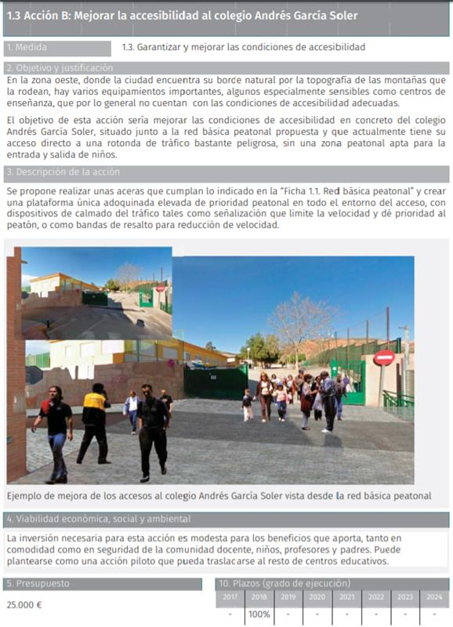

Source: PMUS Lorca. Plan de Movilidad Urbana Sostenible movilidad Piura, 139, catalogue of actions, costs and financing (this figure shows 2 of 8 pages)
Basic element 15. Presentation of costs and financing for every measure. Note: Source, Plan de movilidad Piura, 139, catalogue of actions, costs and financing (this figure shows 2 of 8 pages)
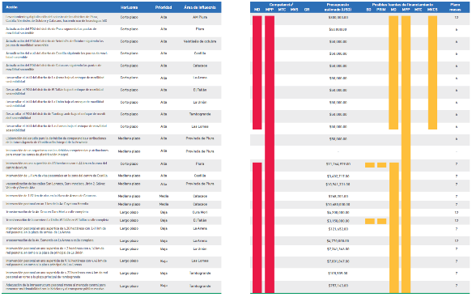

Capacity development strategy

Basic element 16. Capacity Development Strategy. Note: Source: Capacity Development Strategy - MobiliseYourCity Africa Community of Practice

To be added as soon as published

Monitoring & Reporting

Core indicators

Other indicators

Monitoring management

Basic element 17. Monitoring (Template)
MYC SUMP Core Indicators | Base line | Target 2030 (2040/2050) | Application area | Data collection/ Monitoring method | Frequency | Responsibility
Access to public transport | % | % | City
Air pollution | mg PM2.5 | mg PM2.5 | City centre | Air quality measuring station (PM2.5 and NOX) | Data collected on daily basis, monthly report | Environmental department
Road Safety (number of traffic fatalities) | Pers.  (in  thousands) | Pers.  (in thousands)
Modal split (in pkm -not trip) | % | %
GHG emissions from transport | MtCO₂e  per year | MtCO₂e  per year
Additional Indicators
Commercial speed | km/h | km/h
Mobilised public and private funding
Others (city specific)
… add as needed

Appendix

List of contributors to the SUMP development

Timetable of SUMP development

Data collection methods

Participation summary

Description of scenarios

Long list of potential measures

Traffic model report

Data reporting timetable

References

Index of Boxes

Index of Diagrams

Index of Images

Index of Tables

Glossary

Area plans and future development charts

